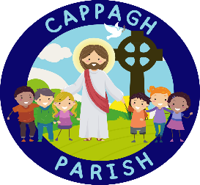
‘Do This In Memory of Me’ Masses
2022 – 2023

Sunday 20th November 2022  12 Noon – Christ the King Church | Feast of Christ the King | Baptism: Called and Chosen: King (Serve)
Sunday 11th December 2022  12 Noon – Christ the King Church | Gaudete Sunday  (3rd Sunday of Advent) | Baptism: Called and Chosen: (Pray)
Sunday 8th January 2023  12 Noon – Christ the King Church | Baptism of the Lord | Baptism: Beloved Sons and Daughters of the Father
Sunday 22nd January 2023  12 Noon – Christ the King Church | Word of God Sunday  (3rd Sunday of Ordinary Time) | Baptism: Called and Chosen: Prophet (Proclaim)
Sunday 19th February 2023  12 Noon – Christ the King Church | 7th Sunday of Ordinary Time | Reconciliation: Choices
Sunday 19th March 2023  12 Noon – Christ the King Church | 4th Sunday of Lent | Reconciliation: We can be forgiven
Sunday 2nd April 2023  12 Noon – Christ the King Church | Palm Sunday | Reconciliation: Christ’s Saving Passion & Death
Thursday 6th April 2023  7pm – Christ the King | Holy Thursday | Eucharist: Communion with God and with one another
Sunday 30th April 2023  12 Noon – Christ the King Church | 4th Sunday of Easter | Eucharist: Thanksgiving
Sunday 11th June 2023  12 Noon – Christ the King Church | Corpus Christi | Eucharist: Procession and Benediction

Weekend Mass Times – Cappagh Parish
Saturday Vigil: 6:30pm – Christ the King Church, Strathroy
Sunday Morning: 9am – St Mary’s Church, Killyclogher
10am – St Mary’s Church, Knockmoyle (every 2nd Sunday – see timetable in Church porch)
10am – Corpus Christi Church, Mountfield (every 2nd Sunday – see timetable in Church porch)
11am – St Mary’s Church, Killyclogher
12 noon – Christ the King Church, Strathroy

