Be Happy!

If you are feeling sad or worried about something, you can talk to…

Mrs Tracey Mrs Mc Elroy

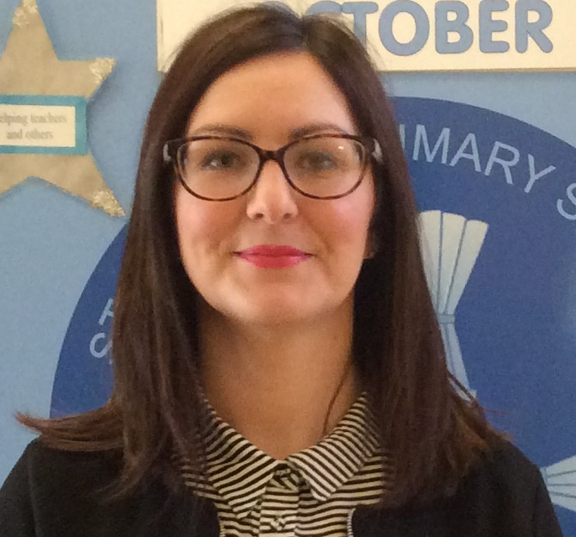
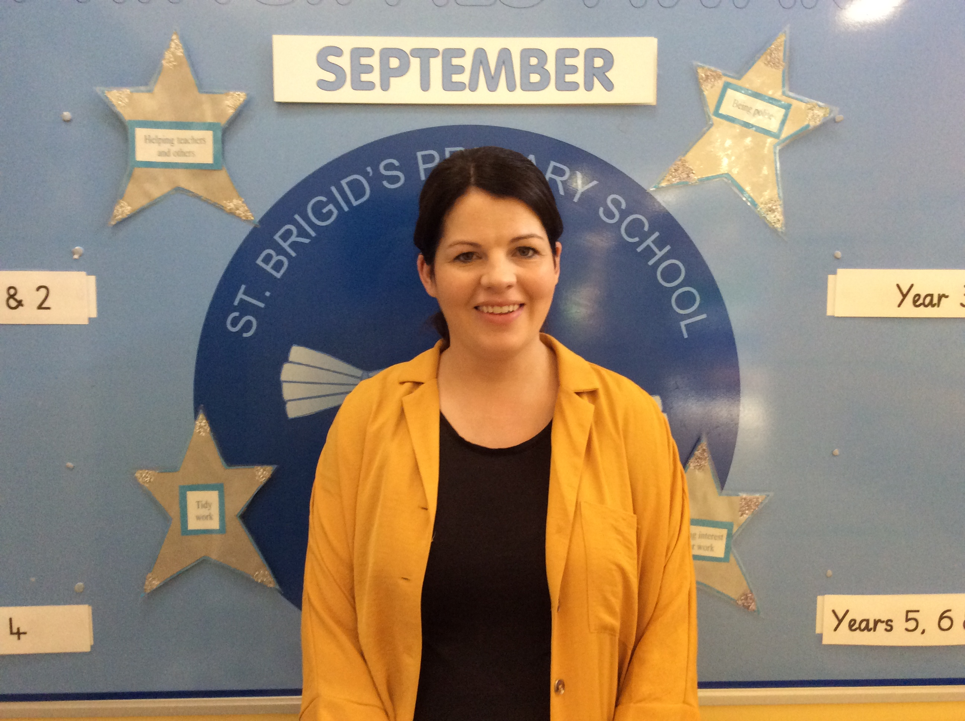

Designated Teacher for Child Protection
Deputy Designated Teacher for Child Protection



