**Safeg**

**Safeguarding Team**

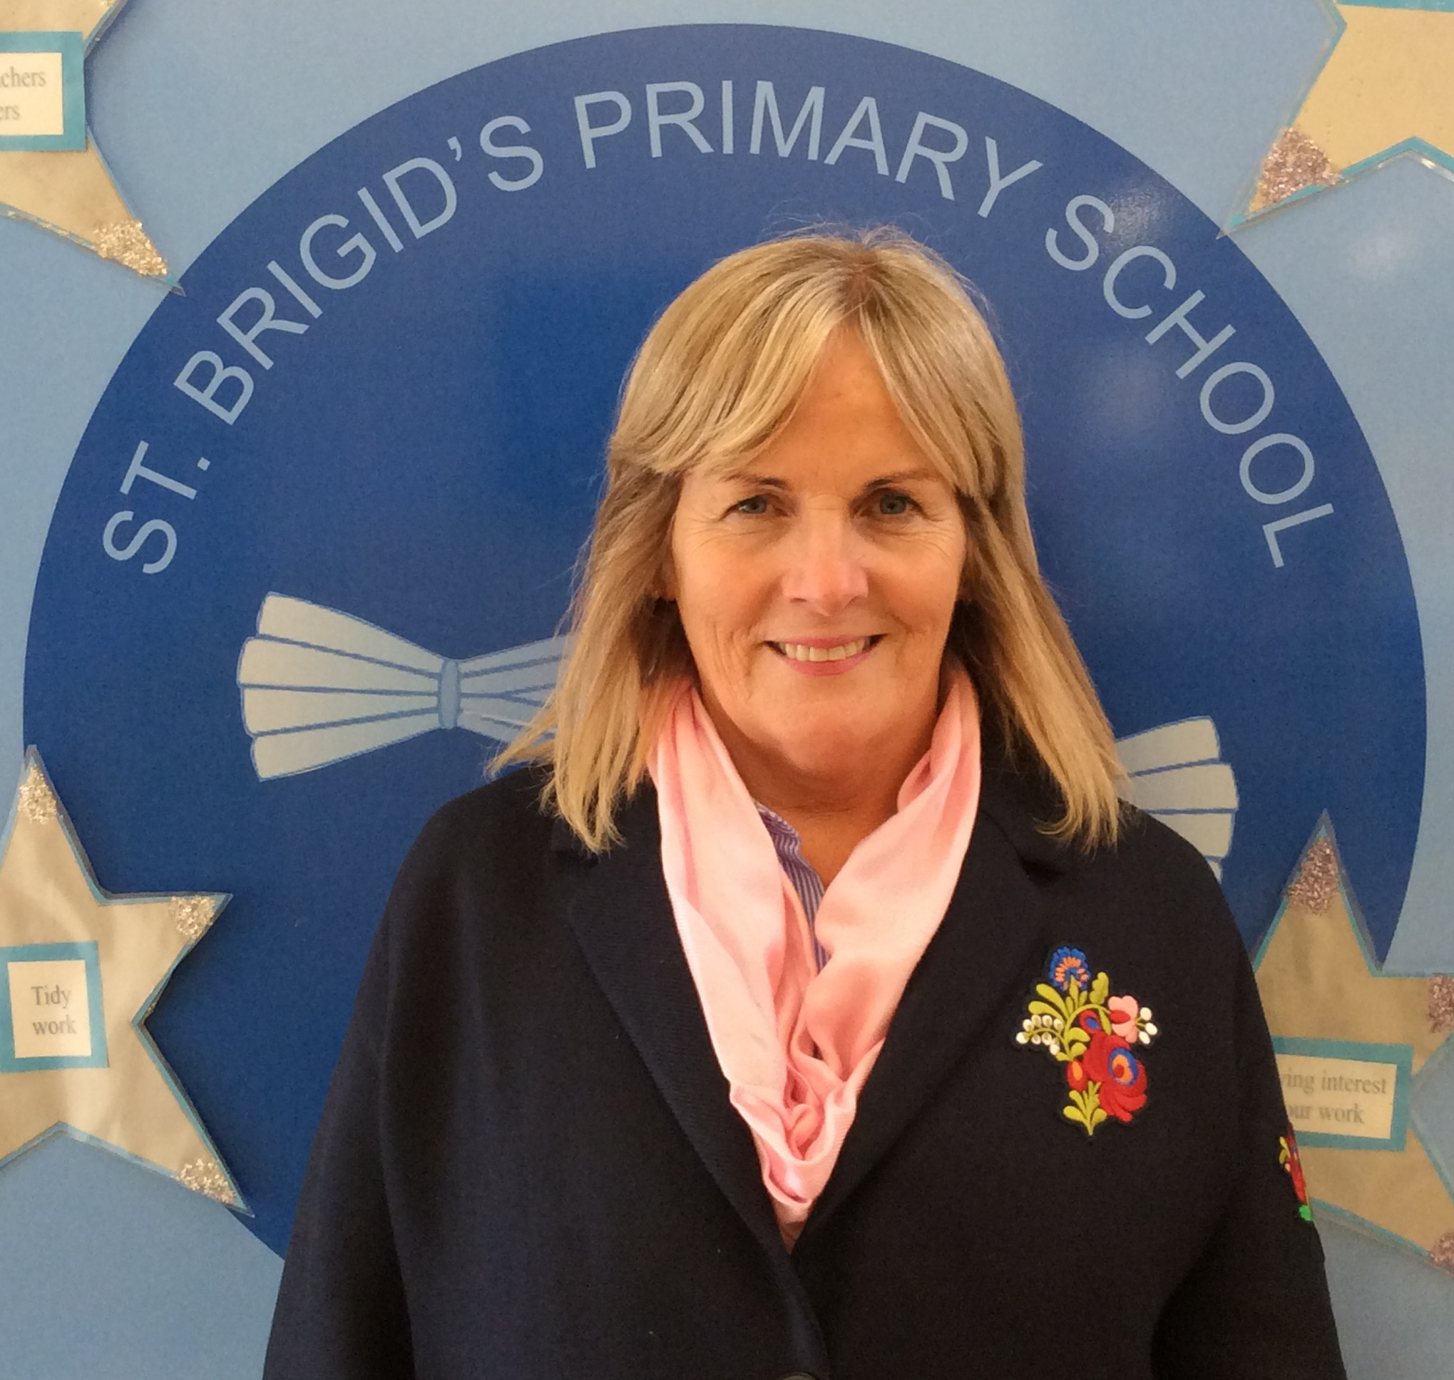

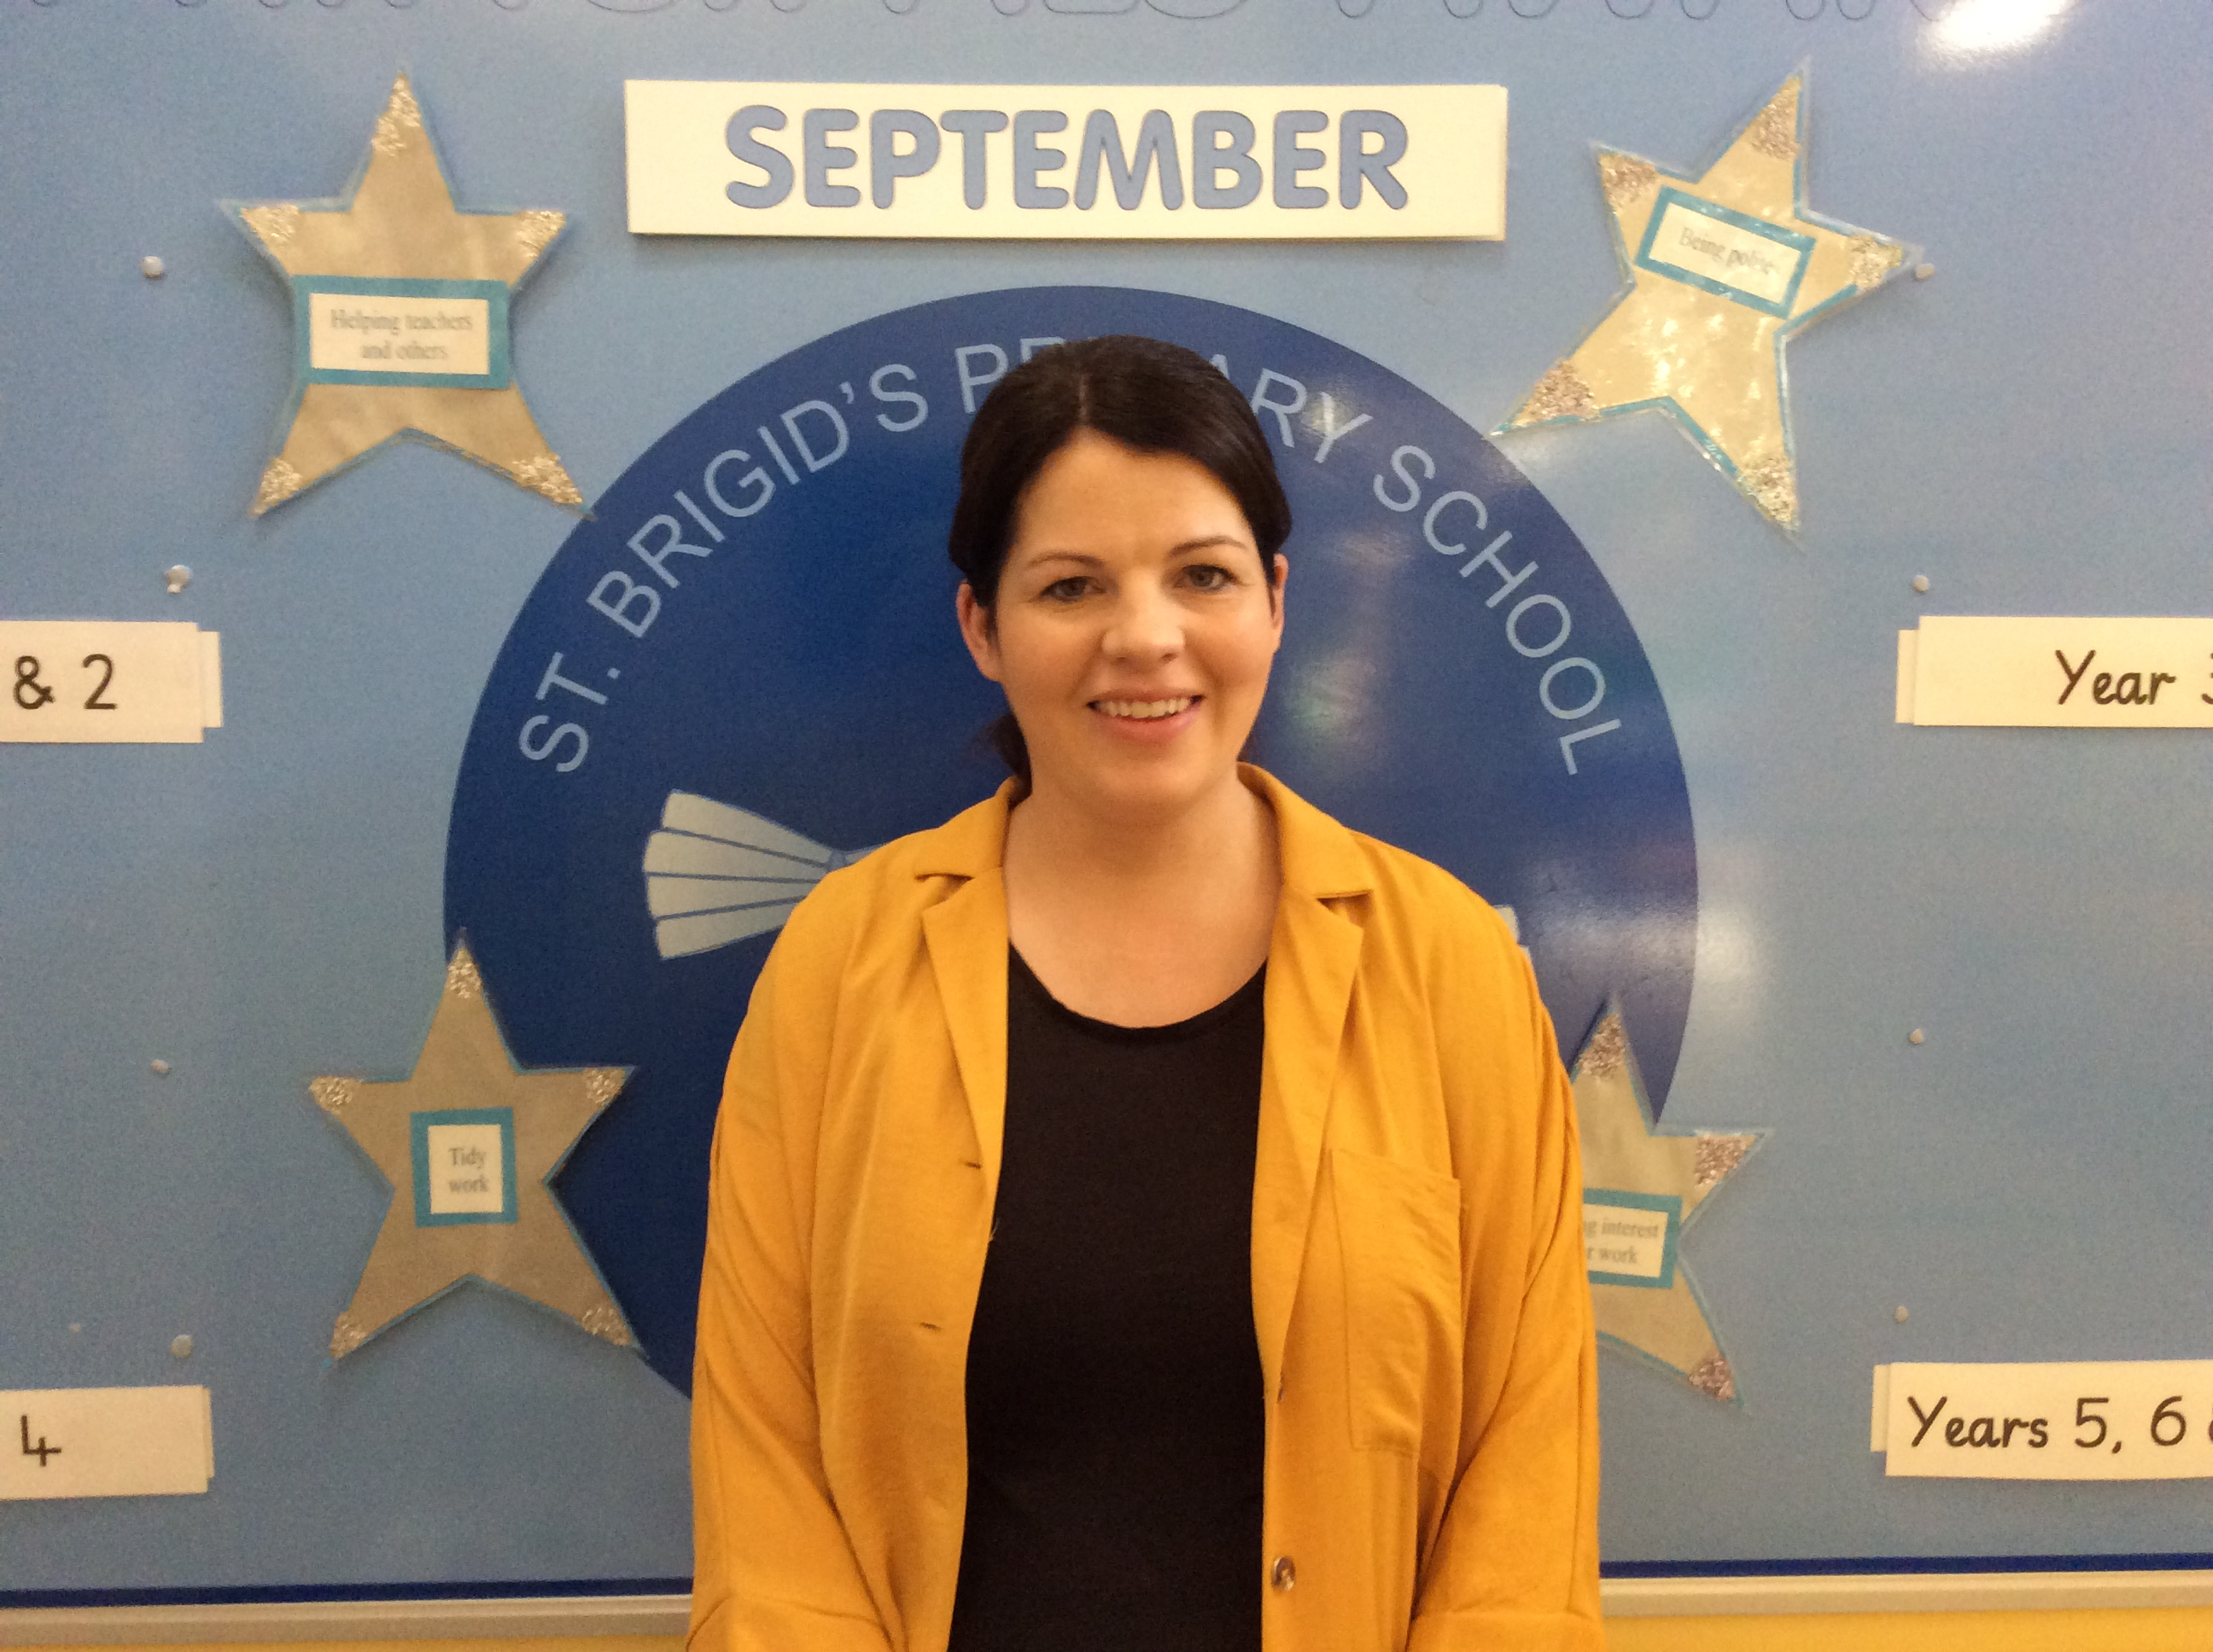



Mrs Donaghy Mrs Mc Elroy Mrs Marian Bradley Mrs Carmel Mc Cloy

Designated Teacher Deputy Designated Teacher Chairperson (BOG) Vice Chairperson

Designated Governor Designated Governor